Usability Report

(on following site: <https://hypermedia123456.herokuapp.com/>)

*INTRODUCTION*This document report the results of usability tests done on the web site designed and created by Nicholas Magatti and Leonardo Panizzo for the exam of Hypermedia Applications at Politecnico di Milano in the year 2019.  
The project is a site for a bookstore that gives the possibility to buy books online and get all the information about the authors and events about the books available.

The report is divided in three part: inspection (where the two members of the group perform a short heuristic inspection of the site), user testing and comparison of the two previous tests.

*INSPECTION*  
The two members of the group made an individual evaluation of the site, giving scores to some specific heuristics (described below) assigning points (from 1 to 5) and adding short comments.  
The results has been summed up and pictures have been added to help the reader see the actual screen of the situation described.

The **heuristics** chosen for the inspection are the following:

**NAVIGATION**

- **Interaction consistency:**   
do pages of the same type have the same links and interaction capability?

- **Group navigation:**  
 is it easy to navigate among group members and from a group introductory page to group members (and the other way around)?

- **Structural navigation:**   
is it easy to navigate among the semantic components of a Topic?

- **Semantic navigation:**   
is it easy to navigate from a Topic to a related one?

- **Landmarks:**   
are landmarks useful to reach the key parts of the web site?

**CONTENT**

- **Information overload**:   
is the information in a page too much/too little?

**LAYOUT**

- **Text lay out:**   
is the text readable? Is font size appropriate?

- **Interaction placeholder:**   
are textual or visual labels of interactive elements “expressive”? i.e., do they reflect the meaning of the interaction and its effects? Are they consistent?

- **Spatial allocation:**   
is the on-screen allocation of contents and visual appropriate for their relevance? Are “semantically related” elements close and “semantically distant” element far away?

- **Consistency of page structure:**   
do pages of the same type have the same lay out (same visual properties of each component and similar lay-out organization of the various elements?)

**ERROR PREVENTION**

Note: we added this heuristic to the requested ones because we considered it worth of attention, because not mentioning it would disregard part of the features of the web site.

-**Error prevention**: does the site ether prevents the occurring of errors or ask confirmation before executing a critical action?

**Scores**:

* **N/A**: heuristics not applicable
* Otherwise from **1** to **5**

NOTE:

**1** = the heuristic is not satisfied: multiple severe violations have been detected   
**2** = the heuristic is not satisfied: a severe violation has been detected  
**3** = the heuristic is partially satisfied: with small violations but still acceptable  
**4** = the heuristic is almost fully satisfied: a very small violation has been detected

**5** = the heuristic is fully satisfied: no severe violations has been detected

We(as inspectors) wrote our personal scores with short comments, then compared the data and wrote extended comments in which we summed up all our observations.  
Due to the fact that the given heuristics were often applicable to a series of pages, instead of giving scores page by page, grouping different pages with the same answer for each heuristic.  
The pages that are not reported are implied as N/A.

Then we wrote tables of aggregated data generated with the mean values from the detailed tables.

**Note:**  
By **book**, **event** and **author**, we will refer to pages of single books, events and authors;  
and by **books**, **events** and **authors**, we will refer to the pages of lists of those, as they are called on the toolbar.

C:\Users\Nicholas\Desktop\documenti POLI\terzo anno\HYPERMEDIA APPLICATIONS\PROJECT\DOC DA CONSEGNARE\pictures for docs\toolbar logged.PNG

***RESULTS:***

**Scores by heuristic:**

|  |  |
| --- | --- |
| **HEURISTIC** | **SCORE** |
| **Interaction consistency** | 4.5 |
| **Group navigation** | 5 |
| **Structural navigation** | 5 |
| **Semantic navigation** | 4.3 |
| **Landmarks** | 4 |
| **Information overload** | 4.1 |
| **Text lay out** | 4.5 |
| **Interaction placeholder** | 5 |
| **Spatial allocation** | 4.5 |
| **Consistency of page** | 3.5 |
| **Error prevention** | 5 |

**Scores by dimensions:**

|  |  |
| --- | --- |
| **DIMENSION** | **SCORE** |
| **Navigation** | 4.5 |
| **Content** | 4.1 |
| **Layout** | 4.4 |
| **Error prevention** | 5 |

***HEURISTICS IN DETAIL:***

**INTERACTION CONSISTENCY:**

|  |  |
| --- | --- |
| **SET OF PAGES** | **SCORE** |
| **sign up, log in** | **5** |
| **Contact Us,  Ordering and  Shipping Info** | **5** |
| **book, author,**  **event** | **4** |
| **books, events** | **4** |

**- Sign up** and **Log in**:  
Same kind of content and both containing a link to the other page.

- **Contact Us** and **Ordering and Shipping Information**:  
Static pages with general information. Even if one page has an extra link to the other(despite there is already one on the toolbar), we decided not to count that as a violation, because it would be redundant to have a similar link in the Contact Us page, but it is not for the other page because it invites him/her to contact them in case the information on the page was not enough to help him/her.

- **Book**, **author** and **event:**  
Both event and book pages can easily go from one to the other. It is also easy to reach the related authors and similar books(from a book) and events about the same books(for an event). The only flaw is that the page of the author is only linked to his/her books and not to the events in which the author presents books.

**- Books** and e**vents:**  
They are both search pages, with the link to the object of interest (book/event), a preview of the description and the correlated author, but they have a slightly different interaction with the user.

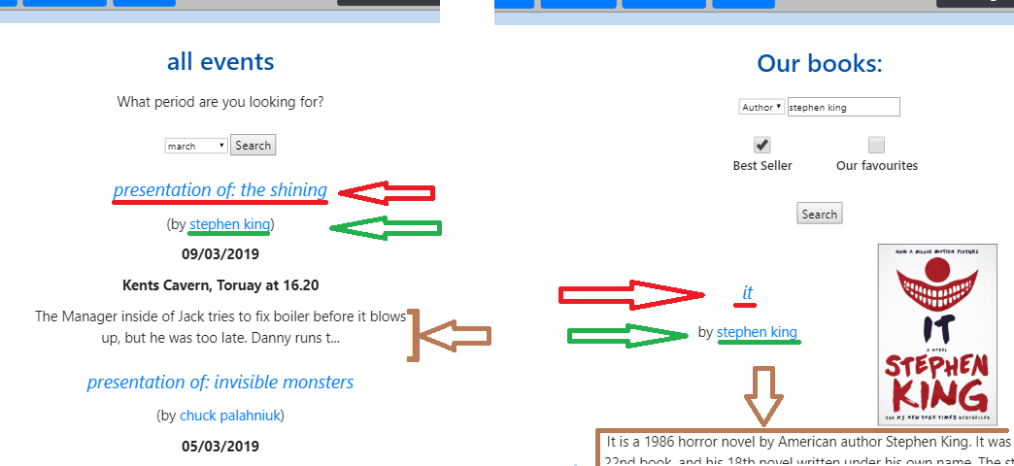

-**Authors**: N/A  
The list of authors has some similarities with the search pages( for events and books), but due to the fact that it is a simple list of authors in alphabetic order, it obviously has different interactions and should not be compared to the two search pages for this specific heuristic.

**GROUP NAVIGATION:**

|  |  |
| --- | --- |
| **SET OF PAGES** | **SCORE** |
| **Books, events, authors** | 5 |

**-books, events, authors:**Navigation is very simple from a group introductory page to group members and vice versa, thanks to the landmarks on the toolbar that always give easy access to groups introductory pages.   
For what concerns navigation among group members, once on the page of a specific member, there is not “previous” or “next” button, but we did not considered that as a violation because in this kind of website, the user doesn’t want a guided tour through group members: it can be useful to be linked to similar books/events or to the books linked to the author, and in fact that is present, but not a guided tour. And if they want to get to another group member, as said before, they can easily go back on the introductory page of that group thanks to the toolbar(see image next page).

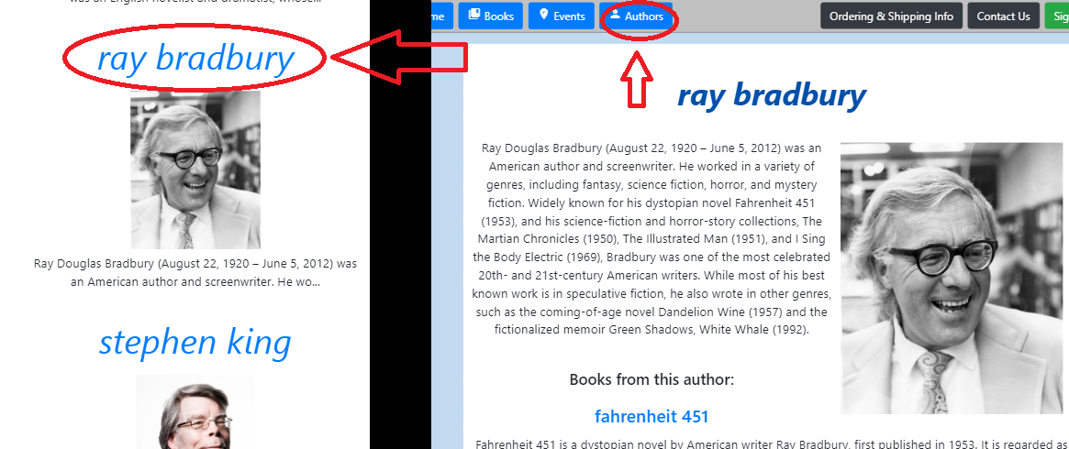

**STRUCTURAL NAVIGATION:**

|  |  |
| --- | --- |
| **SET OF PAGES** | **SCORE** |
| **Book, event, author** | 5 |

-**Book, event, author:**   
It is always easy to navigate among the semantic components of a topic. The links are easily accessible from all these topics that are interconnected with the respective links.

**SEMANTIC NAVIGATION:**

|  |  |
| --- | --- |
| **SET OF PAGES** | **SCORE** |
| **Event, book** | 5 |
| **author** | 3 |
| **cart** | 5 |

**-event, book:**There is a direct link to all the related topics: related events, books, author.

-**author**:  
Authors are directly linked only to their books: if a user wants to see the events in which the author X presents a book, the web site does not help: she/he should click on every book of the author and check the events indirectly.

**-cart:**   
The cart is clearly linked to all the pages of the contained books and to their authors.

**LANDMARKS:**

|  |  |
| --- | --- |
| **SET OF PAGES** | **SCORE** |
| **All the pages:** | 4 |

C:\Users\Nicholas\Desktop\documenti POLI\terzo anno\HYPERMEDIA APPLICATIONS\PROJECT\DOC DA CONSEGNARE\pictures for docs\toolbar logged.PNG

C:\Users\Nicholas\Desktop\documenti POLI\terzo anno\HYPERMEDIA APPLICATIONS\PROJECT\DOC DA CONSEGNARE\pictures for docs\toolbar not logged.PNG

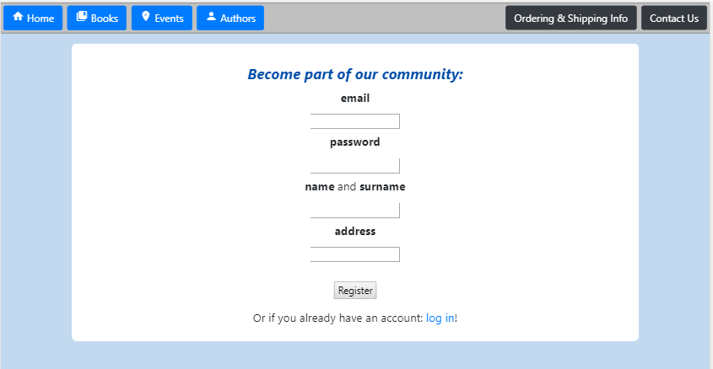

Landmarks on the toolbar give almost always access to all the key parts of the site, but the cart button is showed only when logged in, and the sign up and log in buttons are not exactly definable as landmarks, because are concealed when the user is on one of the pages that they send to.   
This are still not counted as very problematic violations because the user will need the cart only when logged in and won’t need the sign up or login button when already on one of those pages. We decided not to give the highest score though, because there is a chance in which a user may click on the wrong button (let’s say it is the sign up button) and will be annoyed by the fact that the login button had disappeared, even if there is a link to the login at the bottom of the page (and vice versa with the login page).  
 **INFORMATION OVERLOAD:**

|  |  |
| --- | --- |
| **SET OF PAGES** | **SCORE** |
| **home** | 3 |
| **Contact Us** | 5 |
| **Ordering and**  **Shipping info** | 3 |
| **cart** | 3 |
| **Sign up, log in** | 5 |
| **Books, authors** | 5 |
| **events** | 5 |
| **event** | 5 |
| **author** | 4 |
| **book** | 3 |

**-home:**The information on the page has been kept to the minimal, to quickly describe the main features offered by the site, letting the user discover them clicking on the toolbar buttons. The problem is that for a new user, this site may seem as a site of a book store that does not sell online. There is the “Ordering and Shipping” button, but it would have been better to write that in the description as well.  
[picture in the next page]

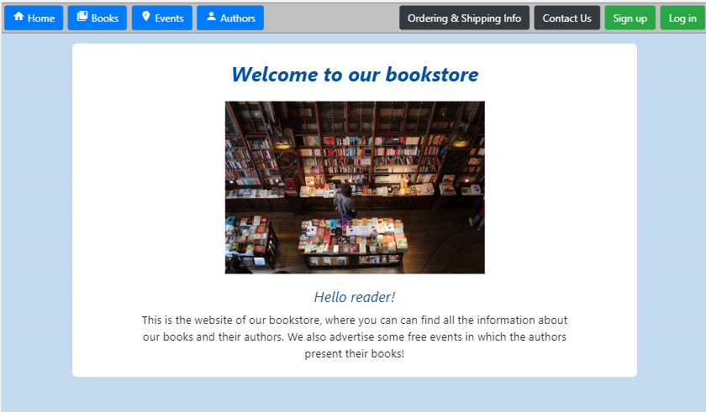

-**contact us:**All the information needed is provided, without overloading the user with other information that belongs to other contexts.

-**ordering and shipping information:**E-commerce web sites usually have very detailed information about ordering and shipping. This is why, even if the site exists just for the purpose of an exam (so it doesn’t contain information about credit card details etc.), we decided to judge this page as too basic; still without considering this as a very severe  
violation because the most important information is clearly available. 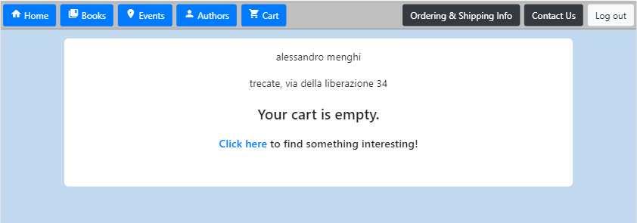

-**cart**:   
The total cost of the order is missing, but for all the rest, it gives all the information about the products and when the cart is empty, invites the user to go to the search page for books, to find something of interest.

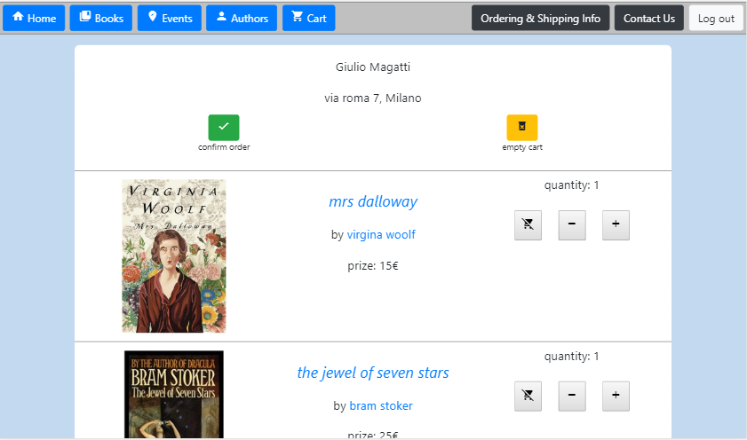

-**signup, login:**   
Very simple: just a form with the link to the other page (sign up or log in).

-**books, authors:**Minimal pages with all the information needed and short previews of descriptions.

**-events:**The information needed is clearly given, also with a short preview of the description of the events.

-**event**: all the relevant information is present without overloading the user.  
 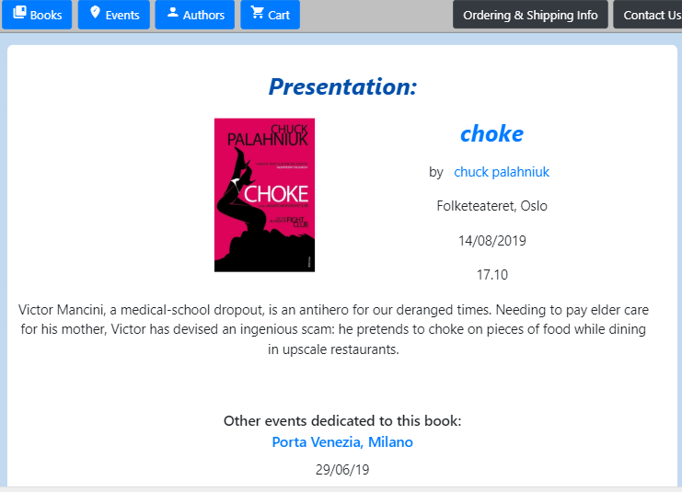

**-author:**Very minimal: as said before, there is the downside of the lack of events linked to the author.

**-book**: It is not a severe violation, but there is a little overload of information for a new user. It is still not overwhelming because it is not all on the screen, but the user has to scroll down to get to the reviews, the events and the similar books. Especially for the similar books, they may be difficult notice for inexpert users.

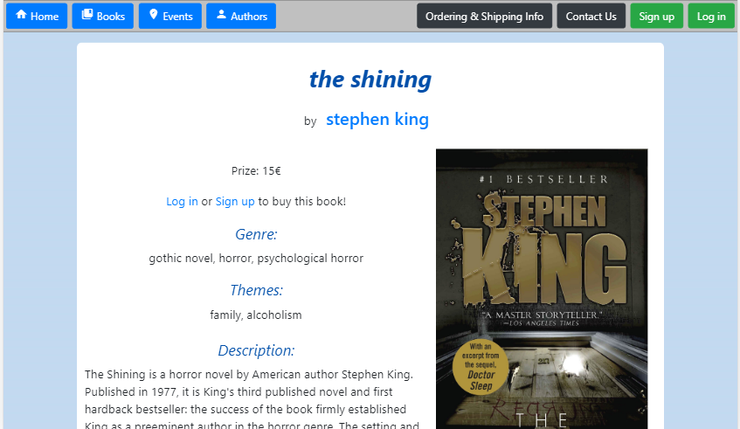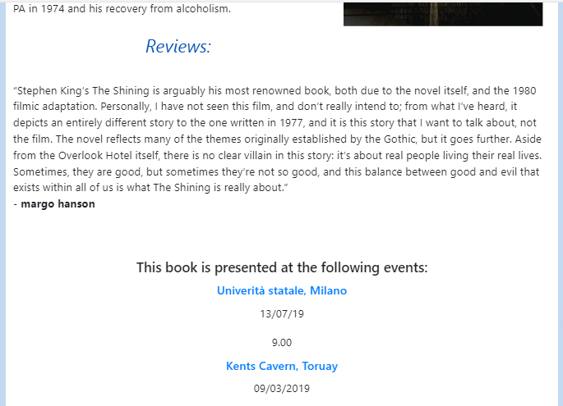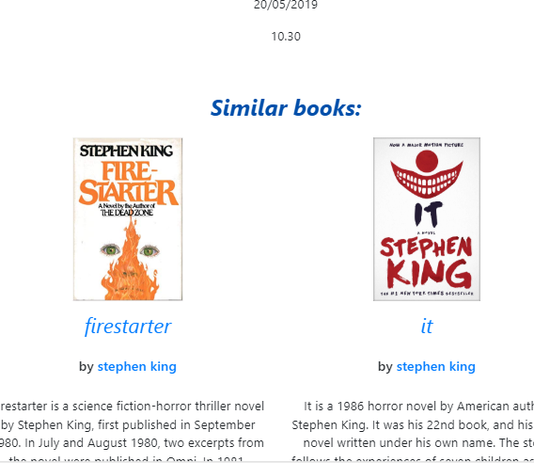

**TEXT LAY OUT:**

|  |  |
| --- | --- |
| **SET OF PAGES** | **SCORE** |
| **authors** | 4 |
| **All the other pages** | 5 |

The title of the page of the authors is smaller than the names of the authors contained, even if there are no problems of readability. All the text in the rest of the site has always an appropriate size and is clearly readable. 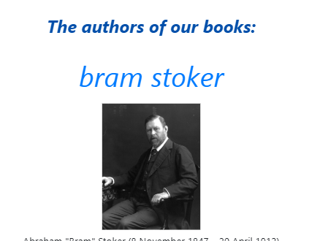

**INTERACTION PLACEHOLDER:**

|  |  |
| --- | --- |
| **SET OF PAGES** | **SCORE** |
| **all** | 5 |

The bigger is a label, the more important is in that context. If a label is also a link, it will have the color that is used for links (rule respected in the whole site).   
The few icons clearly express the meaning of the button they represent.  
The main interactions are between titles of books, events and authors’ names. Almost wherever they are, books and authors always follow the same pattern of ‘title’ and then ‘by author’ below, except for the page of the author, in which the list of books is below, but that is still consistent because it follows a pattern of displaying the object of interest in that context first and below what is related to that (pattern that is used in events and books too).   
 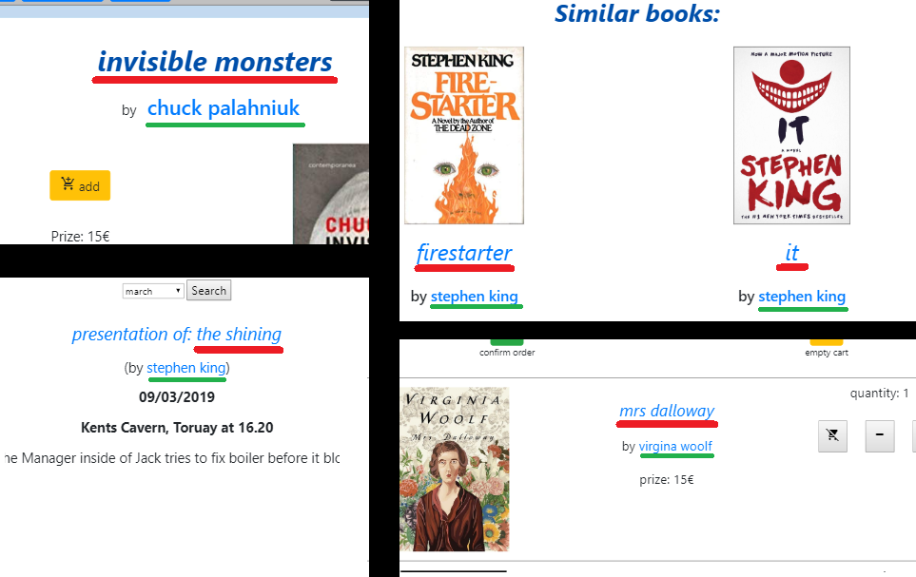

**SPACIAL ALLOCATION:**

|  |  |
| --- | --- |
| **SET OF PAGES** | **SCORE** |
| **toolbar** | 4 |
| **All the pages** | 5 |

**-toolbar:**The buttons for the main actions of the site are on the left, blue, and the others are one the right.  
The buttons for logging in or signing up are close and of the same color.  
Cart and “ordering and shipping info” are related so they are on opposite sides but the closest from the two sides.   
 The small violations detected are the distance between the books button and the cart button.

**-all the pages:**In general, the bigger an element is and the higher it is placed, more importance is attributed to it, in that context. In fact, pages dedicated to a topic have the most important elements at the beginning of the page, and related information on the bottom.

**CONSISTENCY OF PAGE STRUCTURE:**

|  |  |
| --- | --- |
| **SET OF PAGES** | **SCORE** |
| **Book, author, event** | 4 |
| **Cart, books,**  **Events, authors** | 3 |

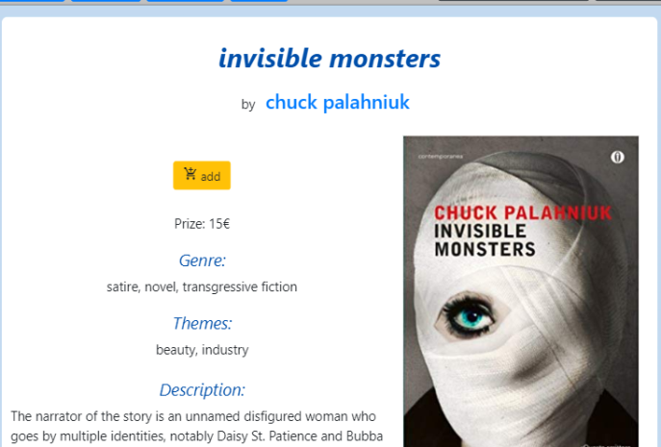  
  
 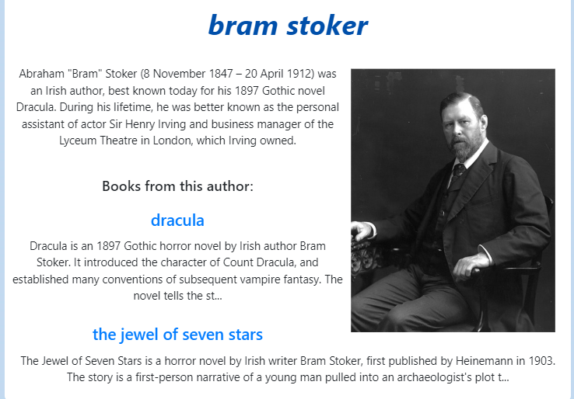

In general, we can say that in every page, dark blue is used for titles that are not links, and light blue for every link. As we can see from the images, they are clearly distinguishable.  
  
-**Book**, **author and event**:  
All of them represent a single topic and are structured similarly, except for the fact that two of them have the picture at the right and the most important information at the left, but the other reverse this order.

**-cart, books, events, authors:**They have similar layout when it comes to links to books and authors names for instance, but they sometimes display the content in one column, sometimes in two or three: so they are not completely consistent in the displaying of lists of elements.

**ERROR PREVENTION:**

|  |  |
| --- | --- |
| **SET OF PAGES** | **SCORE** |
| **Book, event, author** | 5 |
| **cart** | 5 |
| **signup, login** | 5 |

-**book, event, author:**   
The site does not allow the user to go to an inexistent page with any link/button.   
The only way to get an error is if the user tries to modify the url of the page, changing the number at the end, that represents the identifier for an element in the database(example: <https://hypermedia123456.herokuapp.com/pages/book.html?206>). Only in that unlikely situation, the site answers with an error message.  
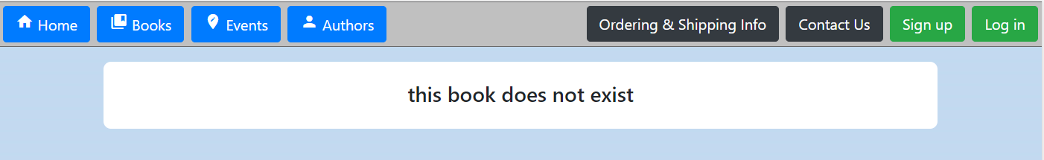

-**cart:**The cart has two button that confirm the order and empty the cart. They are the only critical moves that a user can make on the website so the site always ask for confirmation after a click on those buttons, to avoid unpleasant situations in case of a wrong click.  
And as said before for the page of the topics of book, event and author, this page gives an error message in case the user tries to go on this page when she/he is not logged, writing that in the url of the page, or using the “back” button on their device, and in this case, they also get a pop-up that tells them they are not logged in and sends them to the home page. The same also happens if the user tries that with the signup or login page when he/she is already logged.  
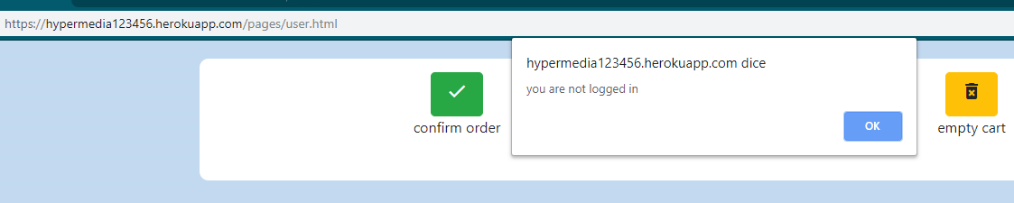  
***CONCLUSION:***On a whole, the web site is well structured but there are some small inconsistencies and missing information.  
The more relevant missing part is the total cost of the order in the cart.  
But we will see from the user testing which of these bother the users and how much.

*USER TESTING*

For the user testing, we used a sample of 5 readers accustomed to purchasing online, between the age of 22 and 30.  
The test took place in the final ecological context of use: at home (of the user). Users have been observed using a video call (using Skype); that made the observer able to constantly see the screen of the user, whom was requested to think aloud during the whole test. For simplicity, the same person took the role of moderator and observer.  
The user was given a paper right before starting the test, so that they could have all the tasks and questions in front of them, but not on the screen of the computer they were using. When giving the paper was not possible, a pdf have been sent to them so they could read that on their phone, in which case they have been asked to set the device to offline mode, to avoid distractions.

How the test was structured:  
The user had to perform some predefined tasks.  
During the performance of a task, the observer had to record the following information:  
**time**(too much, longer than expected, normal, quick), **number of errors**, **task success rate**.  
By error we simply mean a click on the wrong button/link.

“**Normal” duration for tasks:**  
 1) 2 minutes  
 2) 4 minutes  
 3) 50 seconds  
 4) 1.30 minutes

**Task success rate** in details:

* **1**: complete success without assistance
* **0.5**: complete success with assistance or partial success without
* **0**: total failure

**Task 1**: Find if there is any event in which a book is presented near Milan between the 16th of June and the end of that month, possibly after dinner. If yes, check if there are other events dedicated to that book, and if yes, how many are they?

**Task 2**: Buy three books: two copies of a book written by George Orwell that is not “Nineteen Eighty-four” and one copy of a horror that is a ‘best seller’.

**Task 3**: Two weeks have passed but you haven’t received anything yet. Check what the web site says about time of delivery: is it common that your order is taking so long, according to their policies? If not, find a way to contact them.  
  
**Task 4**: Find at least one book that is similar to the novel “Anna Karenina”.

**Goal of each task:**

1) test the readability of the page of the events and see if it is easy for the user to get the faster way to get all the events of a book.

2) test the usability of the sign up system and see if buying a product was intuitive, going through all the critical passages, also including signing up as part of the process, even if that was not requested in the task, because being logged is necessary to buy a product.

3) easiest task: finding the basic information about the site in a brief amount of time. It is more a conclusion of the previous task than a task per se, but we decided to keep them separate because the task 2 is already complex as it is.

4)verify the difficulty of finding similar books, given the fact that information is at the extreme bottom of the pages of single books.

After each task, the user was asked to express the perceived difficulty with a number from 1 to 5.  
Difficulty:

* **1**: very easy
* **2**: small difficulties
* **3**: difficult
* **4**: very difficult but still acceptable
* **5**: too hard

At the end of the test, the tester has been asked the following questions:

1. I found this website unnecessarily complex
2. This website is easy to use
3. Text was hard to read
4. Using this website made me uncomfortable
5. On this website t is easy to find what you need
6. The amount of information on the home page is adequate
7. Colors and navigation is consistent throughout the site
8. It was necessary to scroll often to reach desired information
9. The terminology is understandable throughout the site
10. The text and graphics are presented in a visually aesthetic manner
11. Overall, the pages were quick to load

The possible answers were: **agree**(+1), **disagree**(-1), **strongly agree**(+2), **strongly disagree**(-2), **neither**(+0).

The 5 tests took place in the 16th of June of 2019. We placed the first two appointments at two hours of distance, so that if something had gone wrong, we would have had the time to redesign the test before the appointment with the next.  
Each test had a duration of 20-25 minutes.

***RESULTS:***

The following numbers are the **mean** values of the results got from the five tests.

**Task 1:**

Time: 2 min 57 (longer than expected)  
Errors: 0.2  
Success rate: 0.9   
Difficulty perceived by users: 1.2 (easy)

**Details:**  
Except for one user, it was clear that from an event, you can get the list of all the other events about that book. Even the one who tried to count all the other events about the same book from the list of all the events (from January to December), immediately found the right solution, after the moderator said that the list could have had a thousand events, so that may have not been the smartest way to count events about the same book. 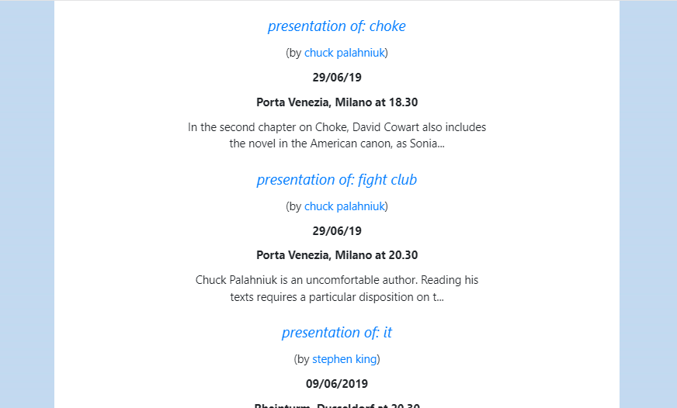  
A user complained about the fact that the list of events did not have a separator between different events: in fact we observed that it took a few seconds for some of them to understand if the title was about what was written below or above.

**Task 2:**

Time: 5 min 22 sec (longer than expected)  
Errors: 0  
Success rate: 1  
Difficulty perceived by users: 1.8 (small difficulties)

**Details:**Even if everybody completed the task without errors or suggestions from the moderator, the heading “sign up or log in to buy this book” has almost always been noticed after a few seconds, even if it was almost on top of the page, right under the prize. It should be easier to notice.  
 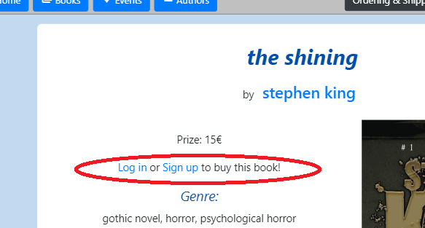  
And some of the users also did not appreciate the fact that after signing up, the site did not bring them back to the page of the book, but to the home page instead, so they had to get to the page of the book again.   
They also complained about the missing total cost in the cart.

**Task 3:**

Time: 41 sec (normal)  
Errors: 0  
Success rate: 1  
Difficulty perceived by users: 1(easy)

**Details:**  
This test was easy as expected. No problems have been revealed.

**Task 4:**

Time: 53 sec  
Errors: 0.2  
Success rate: 0.9  
Difficulty perceived by users: 1.2 (easy)

**Details:**   
The results of this test have been slightly different from what we expected. Regardless the fact that the testers were all accustomed to similar sites, some of them did not immediately get that products similar to X, would have been found from the page of the product X.  
But once on the page of the book, all of them immediately scrolled down and found the similar products: in fact, almost everybody perceived this task as very easy.

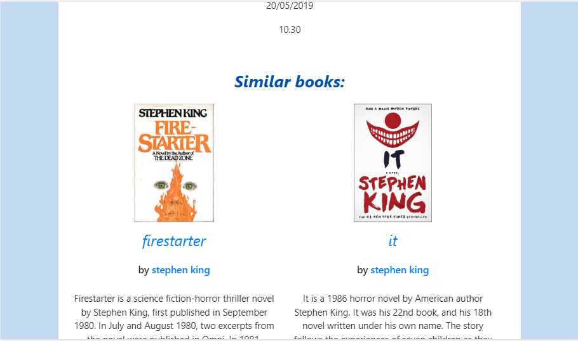

Aggregating the results of the task summaries reported before:

**Mean number of errors**(per task): 0.05  
**Success rate**: 0.95  
**Difficulty perceived by users**: 1.05 (easy)

Note: “time” has been excluded because it is an indicator of value only if referred to a specific task.

**Answers after the test:**

1) I found this website unnecessarily complex: **-1.4** (disagree)  
2) This website is easy to use: **+1** (agree)  
3) Text was hard to read: **-1.4** (disagree)  
4) Using this website made me uncomfortable: **-0.6** (disagree)  
5) On this website t is easy to find what you need: **+0.6** (agree)  
6) The amount of information on the home page is adequate: **+0.6** (agree)  
7) Colors and navigation is consistent throughout the site: **+1** (agree)  
8) It was necessary to scroll often to reach desired information: **-0.8** (disagree)  
9) The terminology is understandable throughout the site: **+1.4** (agree)  
10) The text and graphics are presented in a visually aesthetic manner: **+1** (agree)  
11) Overall, the pages were quick to load: **+1.2** (agree)

***CONCLUSIONS:***

The user testing has shown that the website is easy to use and that new users can get what they want from the site, but it has the following flaws:

* The site do not clearly helps a new user to buy products
* The missing total cost in the cart, make the user doubt the reliability of the site and increase second thoughts about the order
* The margin between different events in the list of events is not enough to be sure whether the titles (that are also the links to the specific events) are referring to what is written above or below
* The fact that after logging in, the site brings the user to the home page and not to the page he/she came from, can annoy the user

*COMPARISON OF THE TWO EVALUATIONS*From both inspection and user testing, the site has been valued positively: no very severe violations have been detected by the inspection and testers gave a positive feedback, regardless of the flaws that they encountered.

What should be done? **What are the priorities?**

Both reports detected the lack of a total cost in the cart: that should be the first amend to make.

The “Login or Sign up to buy this book” near the price for the books should be more visible. This is also a priority because some testers took a few seconds to notice that element and that happened when they were explicitly asked to buy the book. So, a new user who is just reading the information about some book, may not even think about buying anything. We want the user to clearly see that there is the possibility to purchase, even when she/he is not logged.

**Other suggestions for improvements that can be made:**

It would be better if after logging in (or signing up), the user was sent to the page he/she was before.

In the list of events, the margin between events should be increased, so that the user won’t need to make an effort to understand if the link is referred to the description above or below.  
A separating line could also be enough.

The description of the home page should at least contain a few words that explicitly says that the products can be bought online.

Even if none of the testers complained about it, the disappearance of the “sign up” and “log in” buttons on the login and signup pages, may not be optimal: so the permanence of them also on those pages is advised.

Note:   
for the purposes of the exam, we decided to act on five of the six reported problems: all except the third.